PERFORMANCE TESTING REPORTS

2-Load ,stress testing

Made by: ENG : Habiba ragab Abdelmoneam

Load testing

**Tools:Jmeter**

***Load Testing*** is a type of performance testing that evaluates how a system behaves under both normal and anticipated peak load conditions. It is designed to simulate real-world scenarios where multiple users or transactions interact with the system simultaneously, ensuring it can handle the expected workload without significant performan ce degradation

**4**

**The next photos( assending steps to make test plan for load testing to the end of it)**

**Total number of users is 56 user**

**1)**

**2) 3)**

**4- Assume we have 4 test suites**

**(normal user-admin-banker- lemo employee)**

**So we will have 4 thread groups**

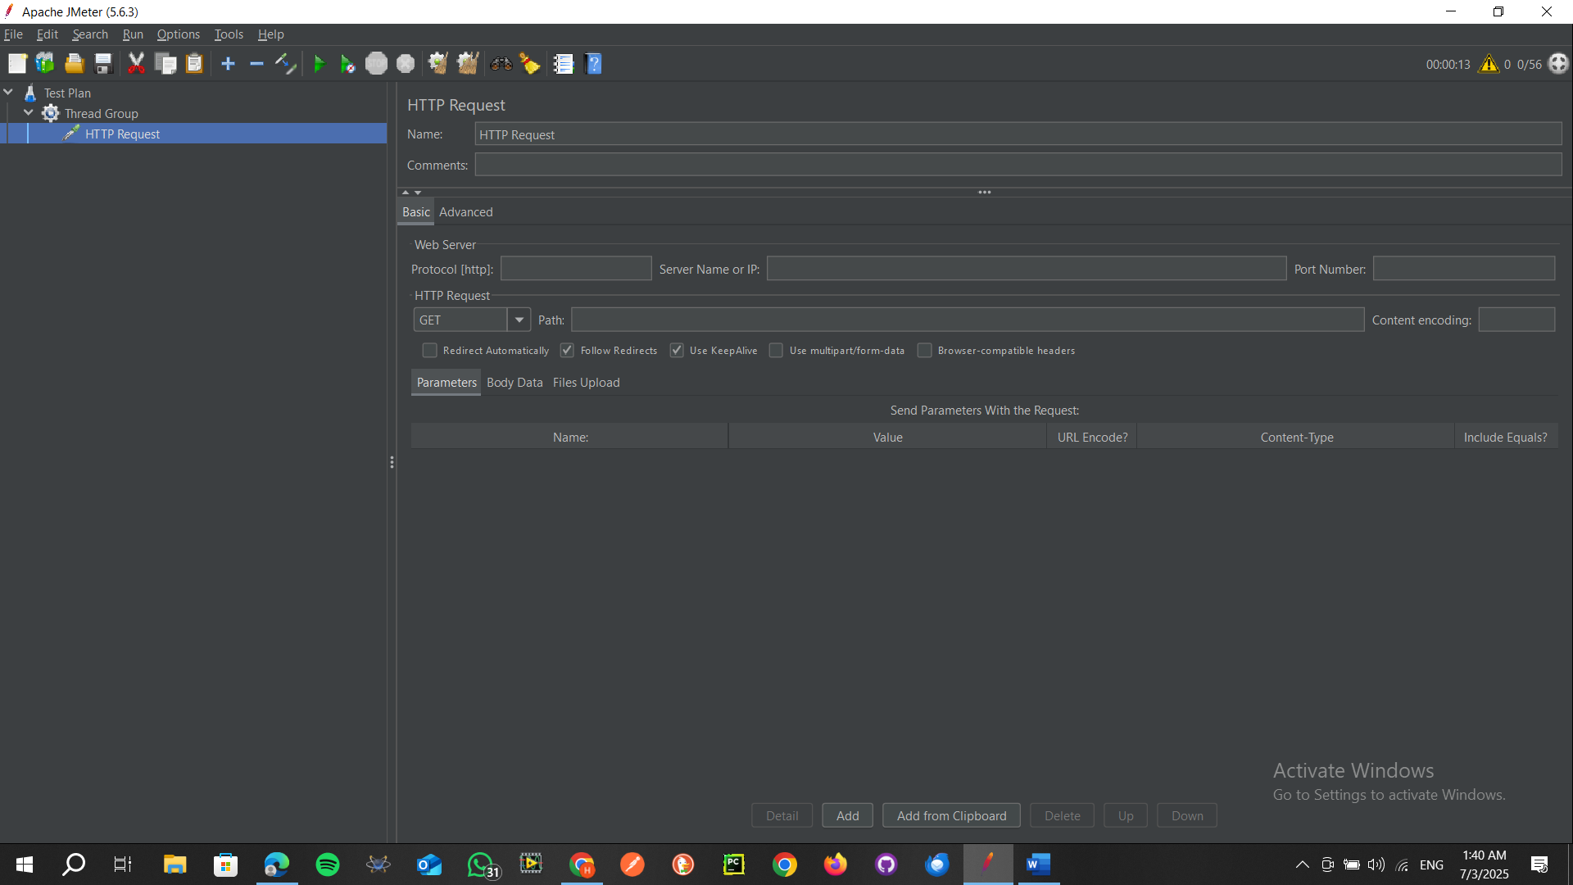

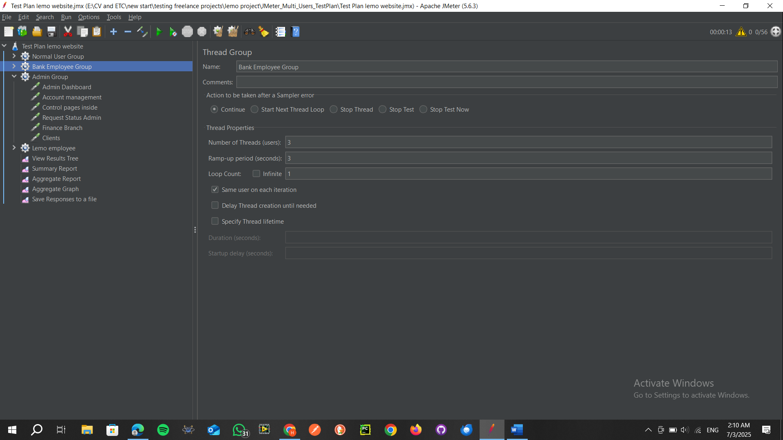

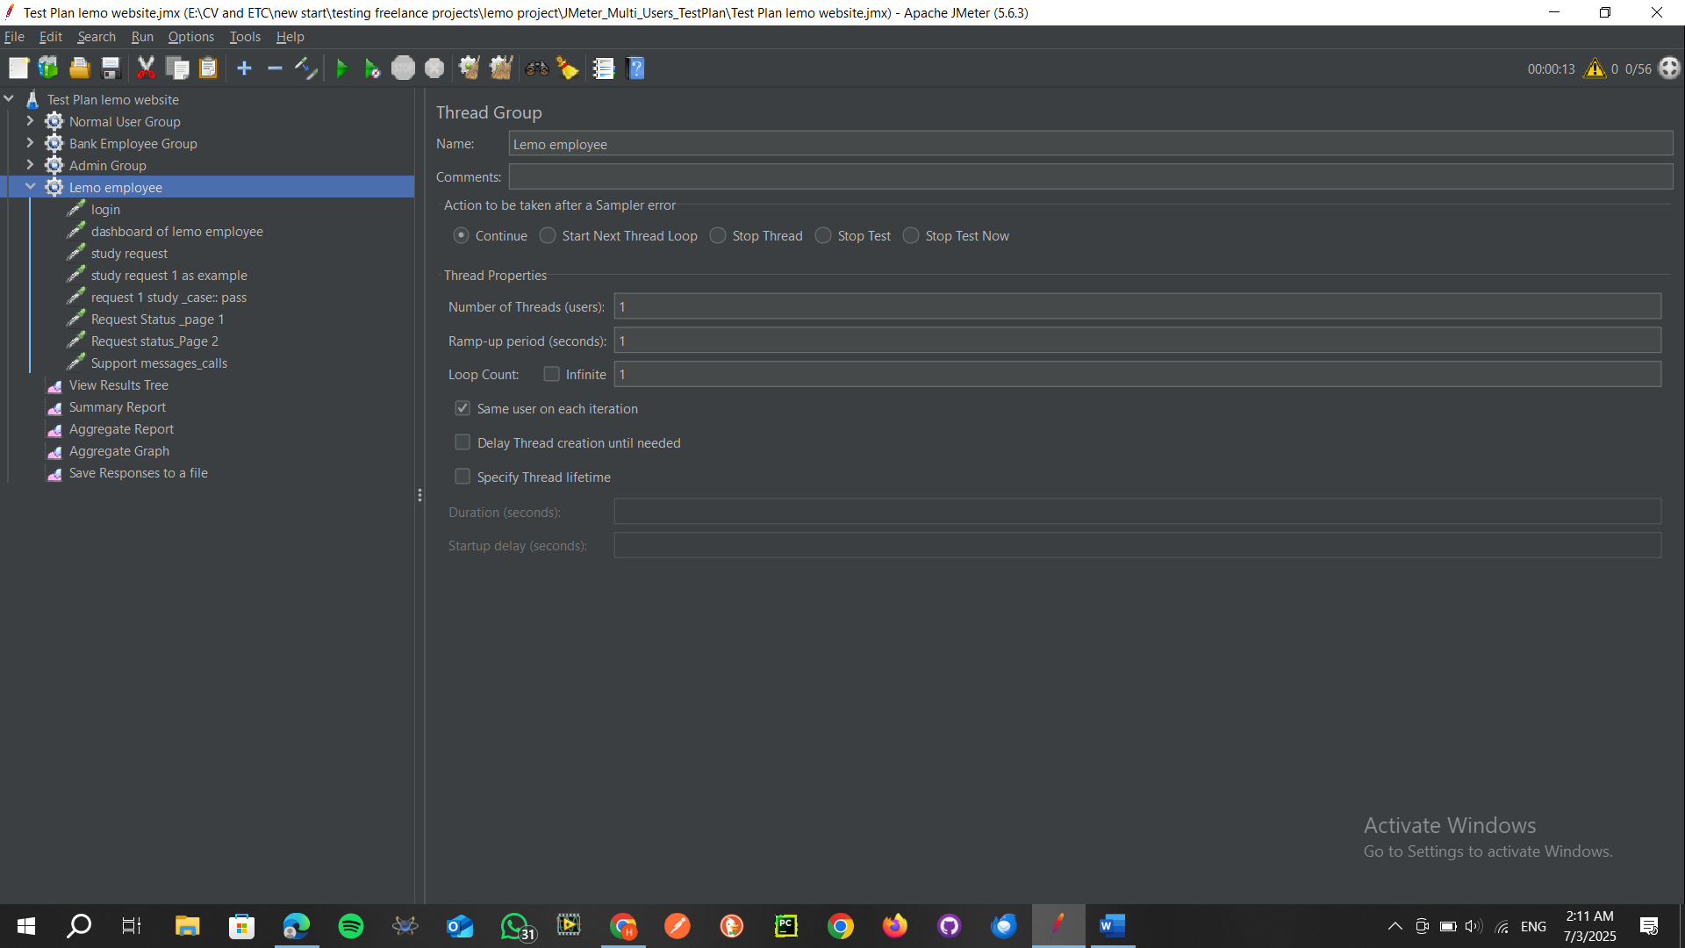

**5) add listeners to generate the reports and graphs**

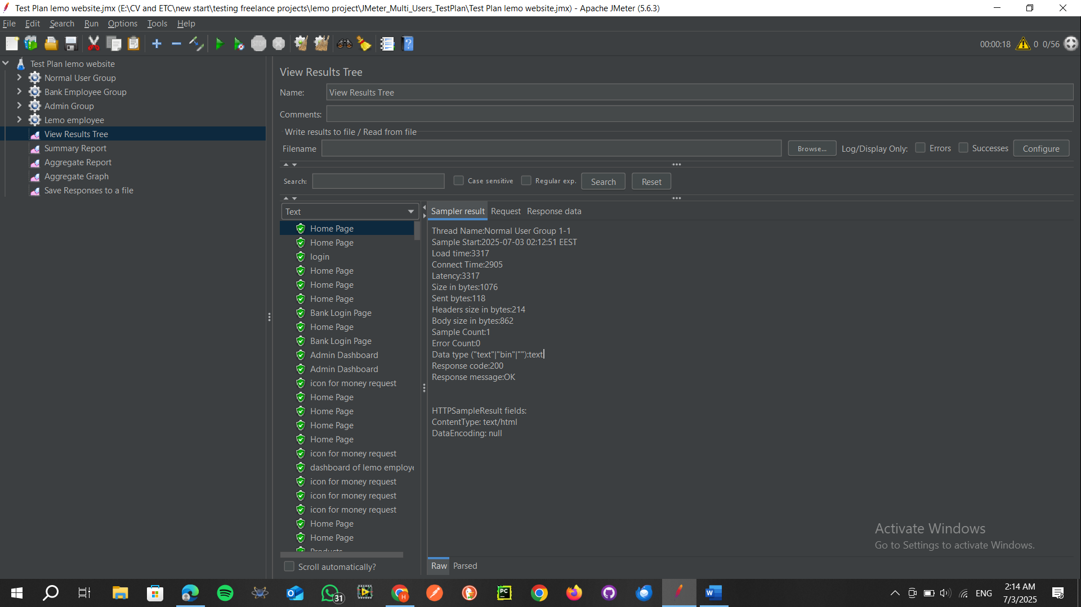

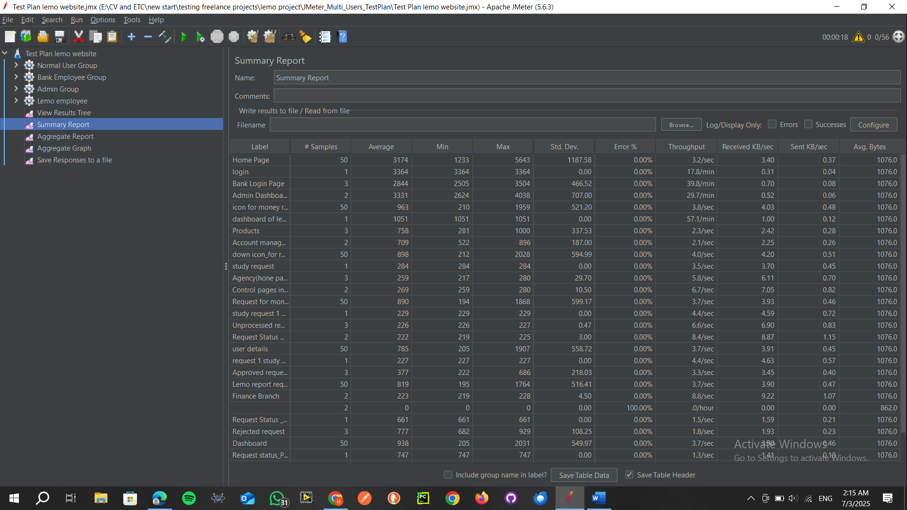

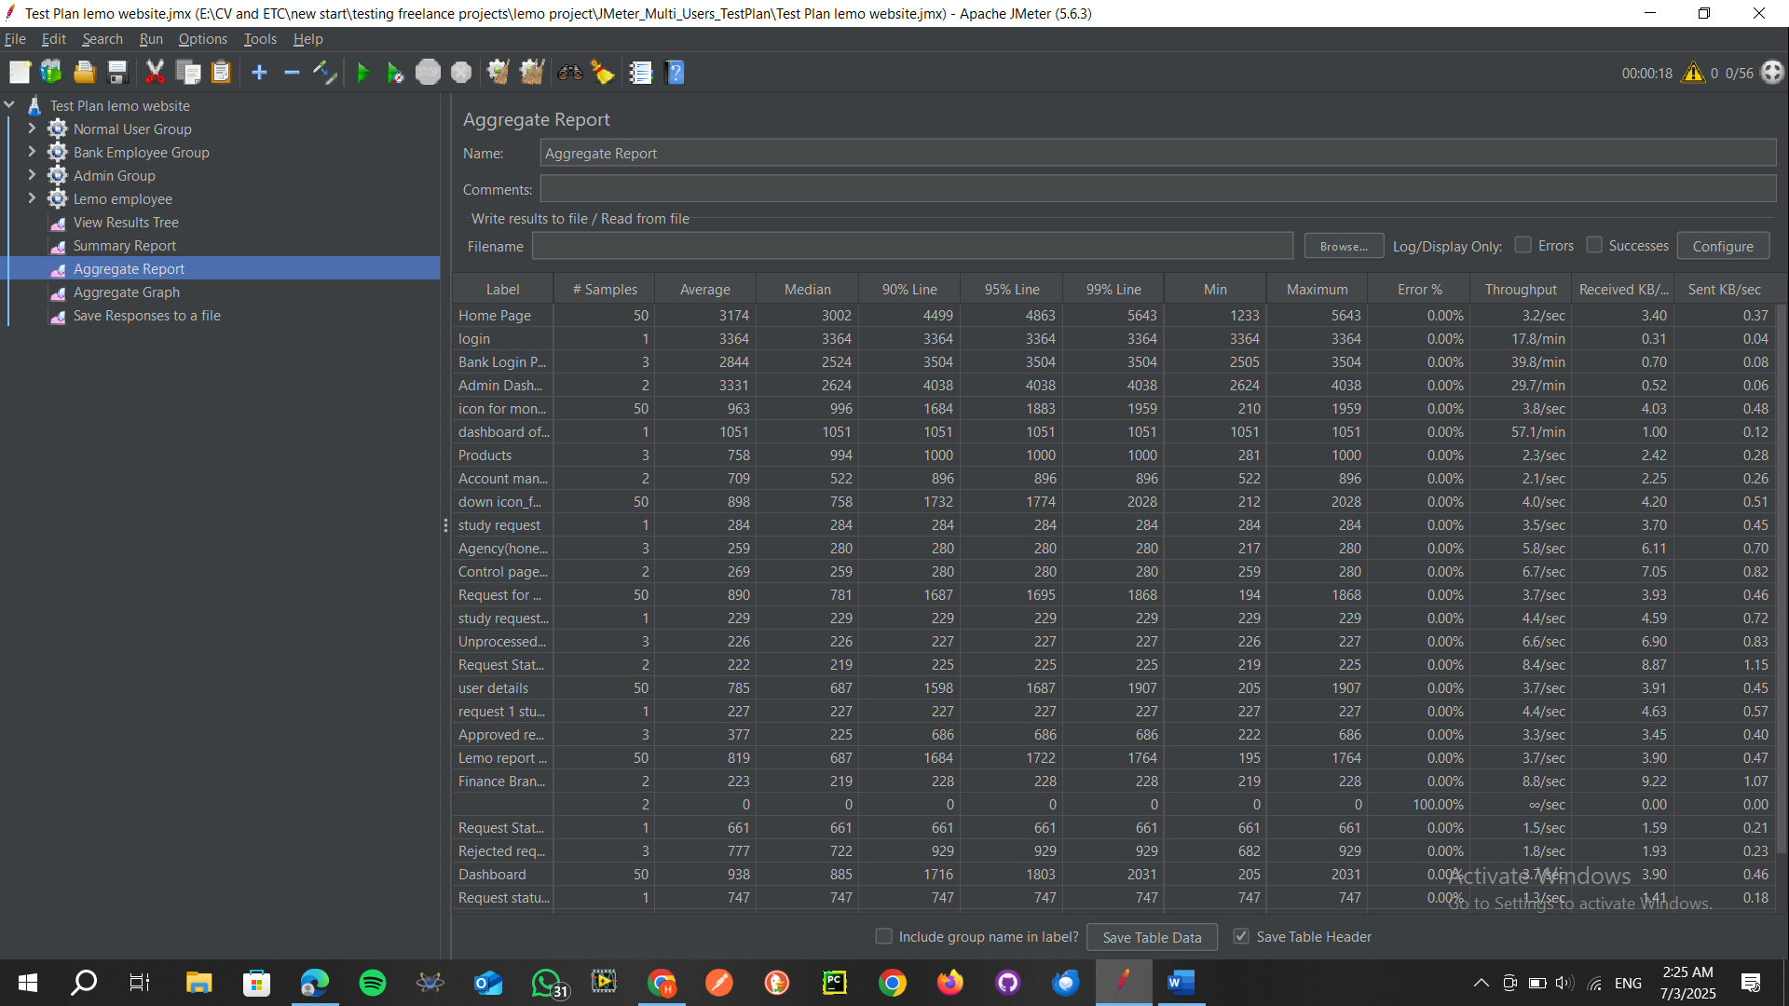

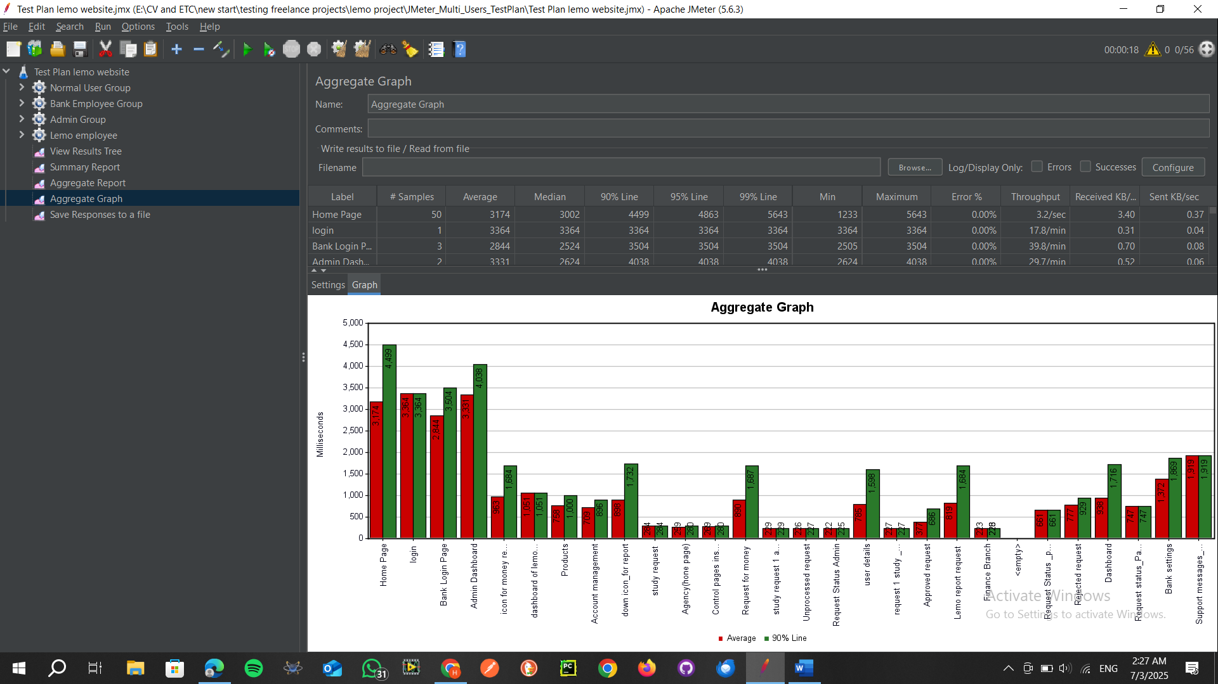

**Stress the same steps but normal users number=100**

|  |  |  |  |
| --- | --- | --- | --- |
| **Scenario** | **Avg Response Time (ms)** | **90% Line (ms)** | **Errors (%)** |
| **Home Page** | **3174** | **4399** | **0%** |
| **Login** | **3364** | **3364** | **0%** |
| **Account Management** | **709** | **896** | **0%** |

**SUMMARY**

**No critical errors were found during the load tests.**  
All main scenarios passed under expected concurrent load.  
Latency is within acceptable range for Account Management, but Home Page & Login show higher average response time.

### **Recommendations**

🔹 **Optimize the backend for heavy pages**

* Focus on Home Page & Login to reduce response time.
* Implement caching and DB query tuning.

🔹 **Monitor server scalability**

* Ensure your servers auto-scale to handle peak loads smoothly.

🔹 **Keep security in mind**

* Perform periodic security tests to cover the 20% security scope.

**Conclusion**

The platform is stable and functional under the tested scenarios.  
With some performance optimization for key pages, the system can achieve faster response times and better scalability, ensuring a smooth experience for your end-user